Job Angels Welcome Page
take the green border off this image Damen
Welcome to Hiring for Hope (HFH), the new home of JobAngels, a grassroots movement, and employment networking program dedicated to bringing people together in a virtual community where each person commits to a single goal: to help just one other person find gainful employment.
Put a space in between here...new paragraph
Effective February 28, 2011 Hiring for Hope and JobAngels have merged in order to quickly expand our outreach and the scope of our complimentary career management services. Going forward, JobAngels will be an official Hiring for Hope career management program, with an ability to expand its effectiveness by operating across both mainstream social media vehicles as well as our Voices of Hope online networking and support community. For more information surrounding the details of this merger, feel free to review the internal announcement and/or press release documents below:

1) Link to Press Release - http://www.hiringforhope.org/pdf/HFH-JA%20Press%20ReleaseFinal%202-11.pdf1) link to press release

2) Link to Internal Announcement - don't have this yet until the last video is done. put this button up there though, so I don't forget will you?
** To learn more about Hiring for Hope and all of our services visit our special JobAngels Welcome Toolkit.
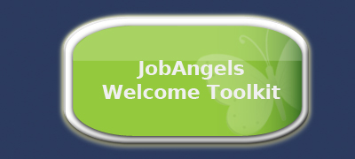

Job Angels Welcome Toolkit
To learn more about Hiring for Hope and all of our programs and services, please visit our website at www.hiringforhope.org, and/or click any of the buttons below to take advantage of the informational materials contained within our JobAngels Welcome Toolkit.
Damen, this section has all new buttons...previous ones didn't look good. Unree made them too purple and all different sizes shapes etc.

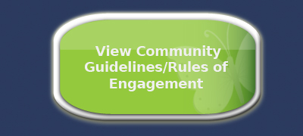
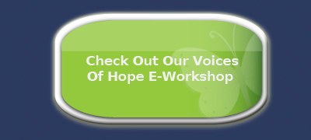
1) Link to View Company Overview Video - http://www.youtube.com/hiringforhope#p/a/u/2/2JBqbXSUlYY
2) Link to Complete Career Management Video - not yet available. put button up though, so I don't forget
3) Check out HFH Website - should go to www.hiringforhope.org
4) View Community Guidelines/Rules of Engagement should go to: - http://hiringforhope.org/job-seekers/Voices_of_Hope-Community_Guidelines-Rules_of_Engagement_Final02-11.pdf
5) Check out our Voices of Hope e-workshop should go to - http://www.hiringforhope.org/archive/voices_of_hope_SCORM/player.html
1. To stay connected with us through our e-newsletter, and/or continue participating in our JobAngels program just click the corresponding green buttons below.

1) Sign up to be a JobAngel - http://hiringforhope-jobseekersvoh.hiringforhope.org/
2) Sign up for E-Newsletter link - http://www.hiringforhope.org/common_forms.html#newsletter
2. To begin taking advantage of our other programs and services, just click the icon(s) below that pertains to your area of interest.
Damen...all new buttons attached to this email in this section. Previous ones were wrong color, shape etc.

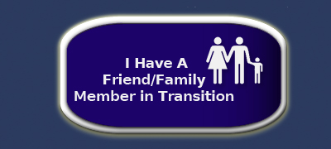

1) link to Job Seeker page - http://www.hiringforhope.org/job-seekers.html
2) link to Employer Partner page - http://www.hiringforhope.org/employers-partners.html
3) Link to Friends/Family page - http://www.hiringforhope.org/friends-family.html
4) Link to Volunteer page - http://www.hiringforhope.org/how-can-i-help.html
5) Link to News Room page for the media button - http://www.hiringforhope.org/news-room.html

Connect With Us - http://www.hiringforhope.org/connect-with-us.html

Damen this should be a separate page vs. just listing it and linking to it on this toolkit page. Should be a link to it on the left hand side of the page too. So basically set up just Like the JA Welcome Toolkit page as far as being a separate page

